ASSESSMENT - 15 | PYTHON - 08

*“FUNCTIONING OF NUMPY”*



Submitted By

VAIBHAV PATIDAR

IPS ACADEMY, INDORE (M.P.)

**Date :** 20-12-2023 | **Day 15**

**Week 3** | **Day - 03**

**What is NUMPY?**

* NumPy is a powerful open-source library in Python for numerical and mathematical operations.
* NumPy provides the **ndarray** (n-dimensional array) for efficient storage and manipulation of large, homogeneous data sets.
* Enables performing operations on arrays of different shapes and sizes, making code concise and readable.

**Important Numpy Functions and Methods :**

1. **type() :** will return the type of the arr object.
2. **.ndim :** will return the number of dimensions or axes of array.
3. **.shape :** wil return the shape of array.
4. **.size :** will return the size i.e. totak number of elements in the array.
5. **.dtype :** will return the typ of elements in the array.

**Writing python program to explain the above commands :**

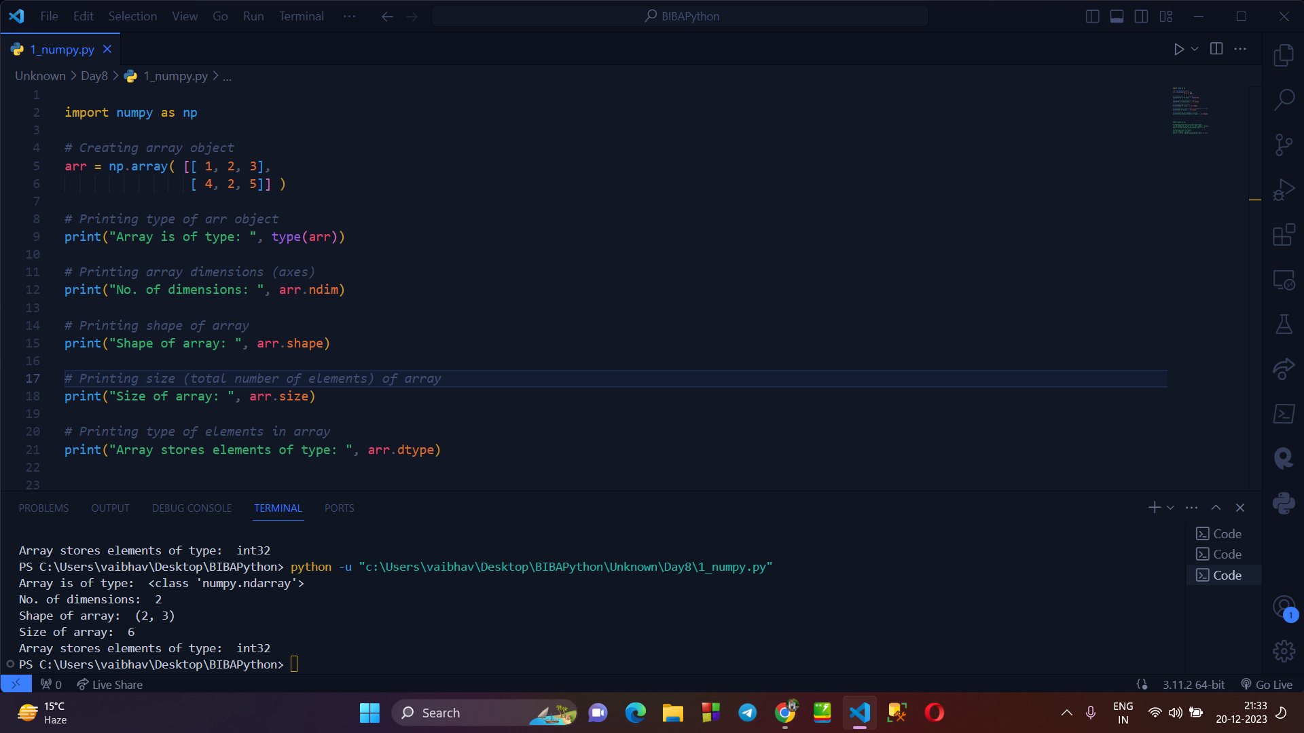

**Different types of creating array using Numpy :**

* There are several types of arrays are created using numpy. Like : 1d, 2d, with zeroes, with ones, etc .
* 1D Array
* 2D Array
* Array with Zeros
* Array with Ones
* Array with a Range
* Identity Matrix
* Random Array

**Program to explain all the above types :**

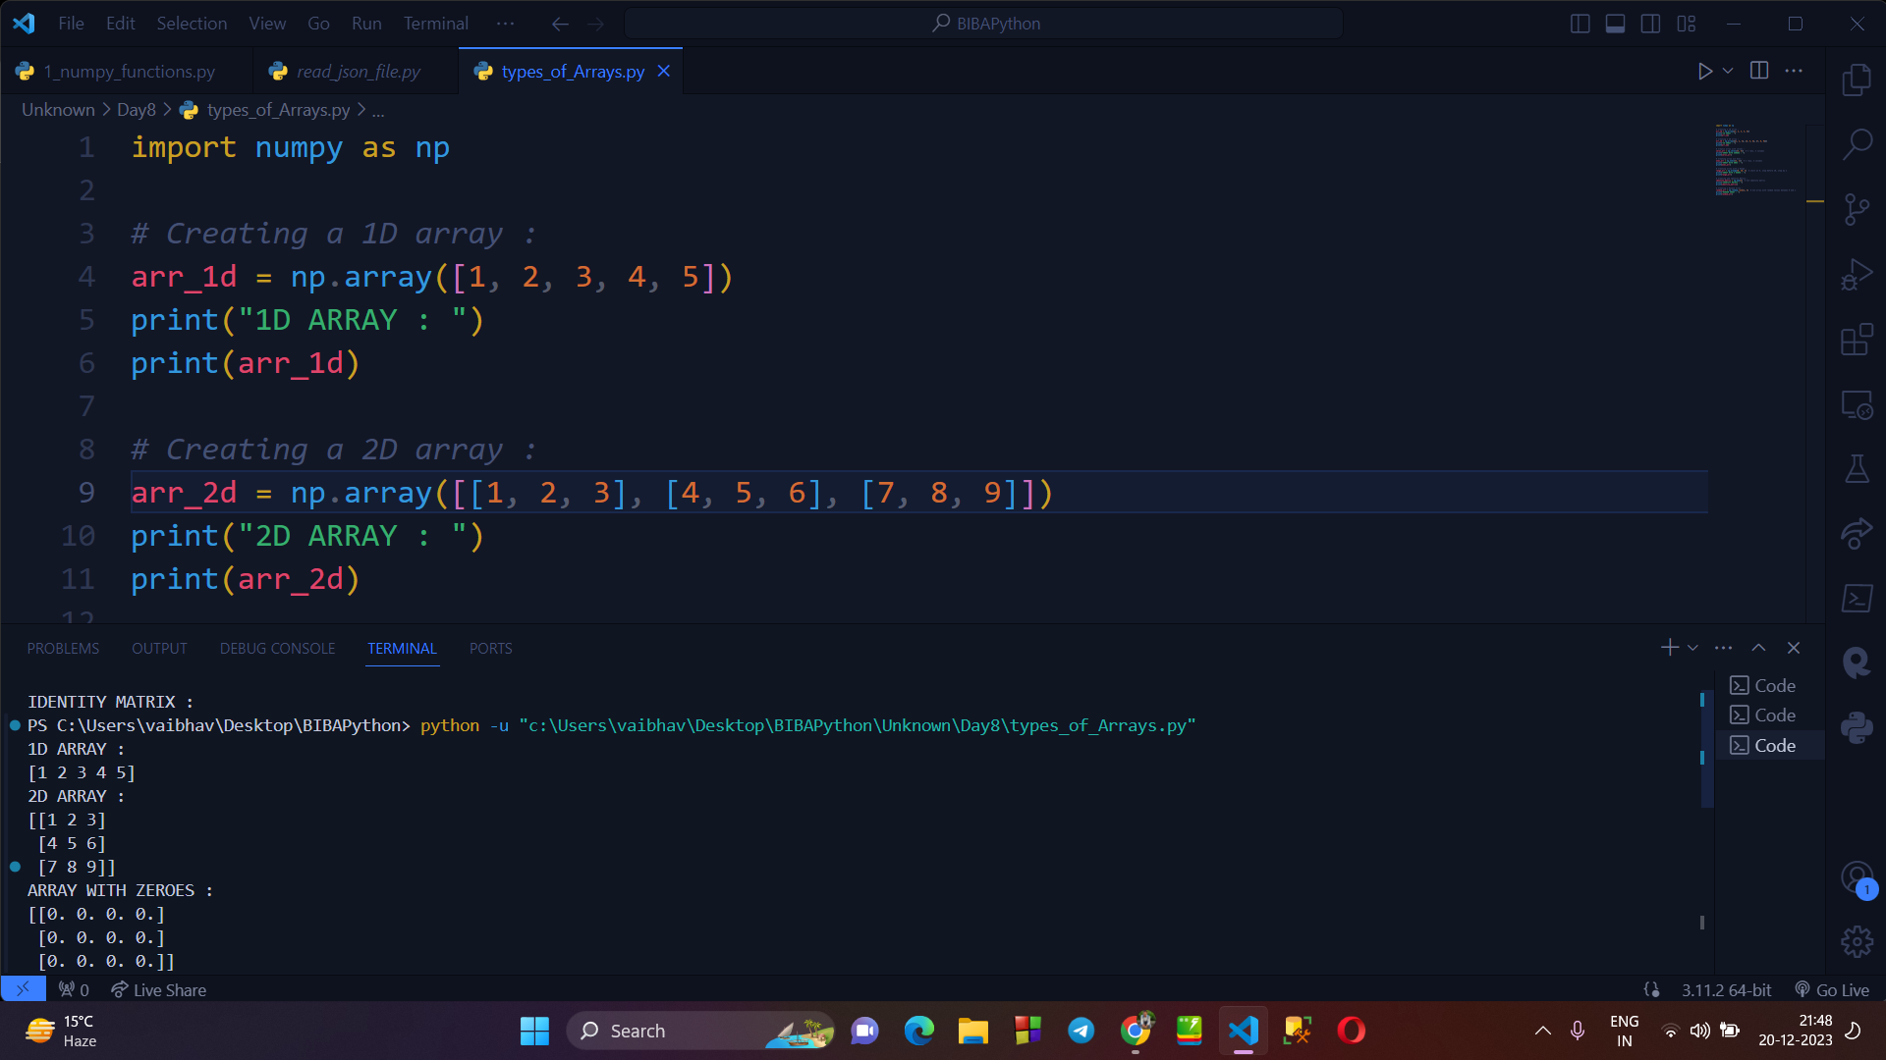

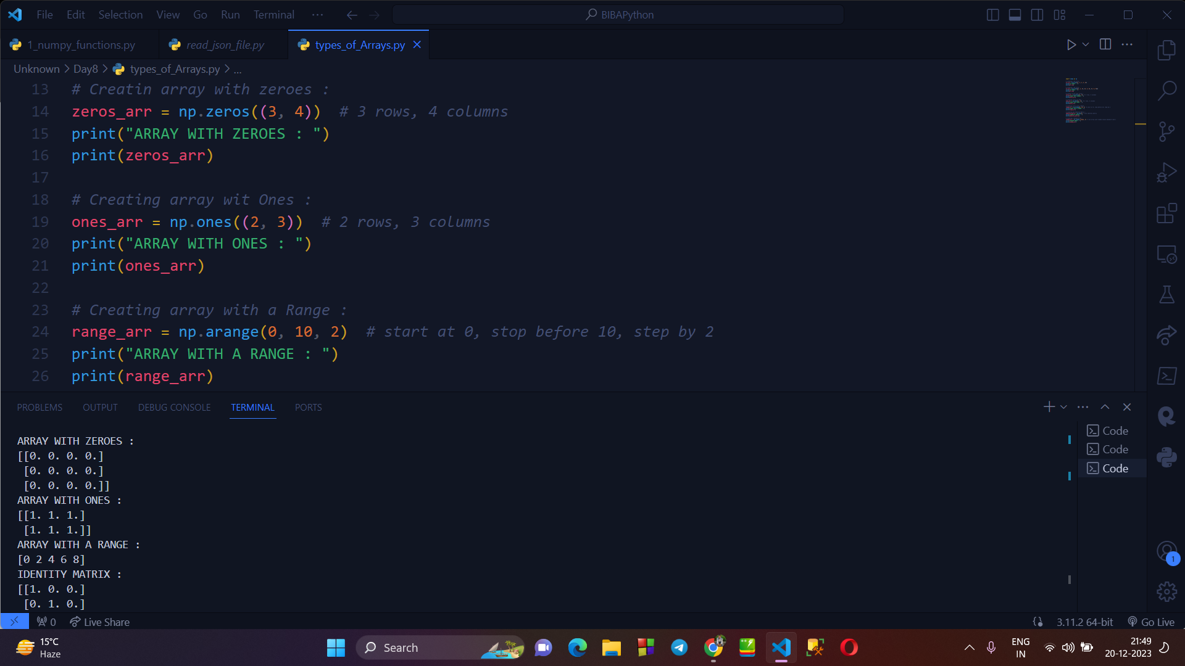

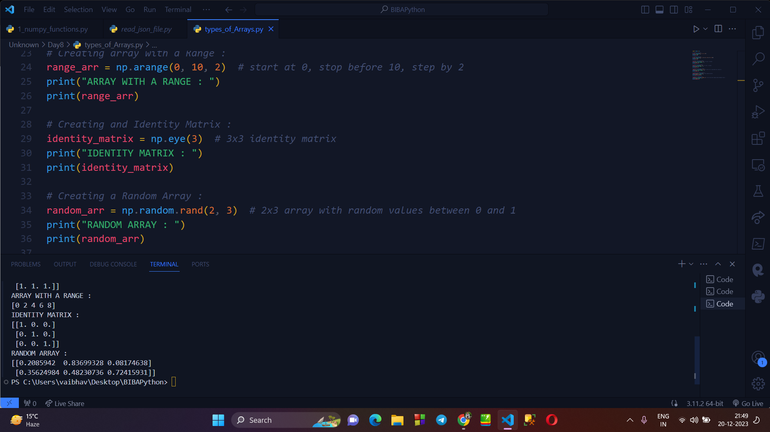

**→ Numpy Basic Operations :**

* Numpy also allows us to perform several operations on the arrays. This include :
  + Arithmetic Operations (+ , - , * , /)
  + Matrix Multiplications
  + Aggregation Functions (Sum, Mean, Max, etc)
  + Array Slicing

**Writing program to explain above operation :**

**→ Arithmetic Operations :**

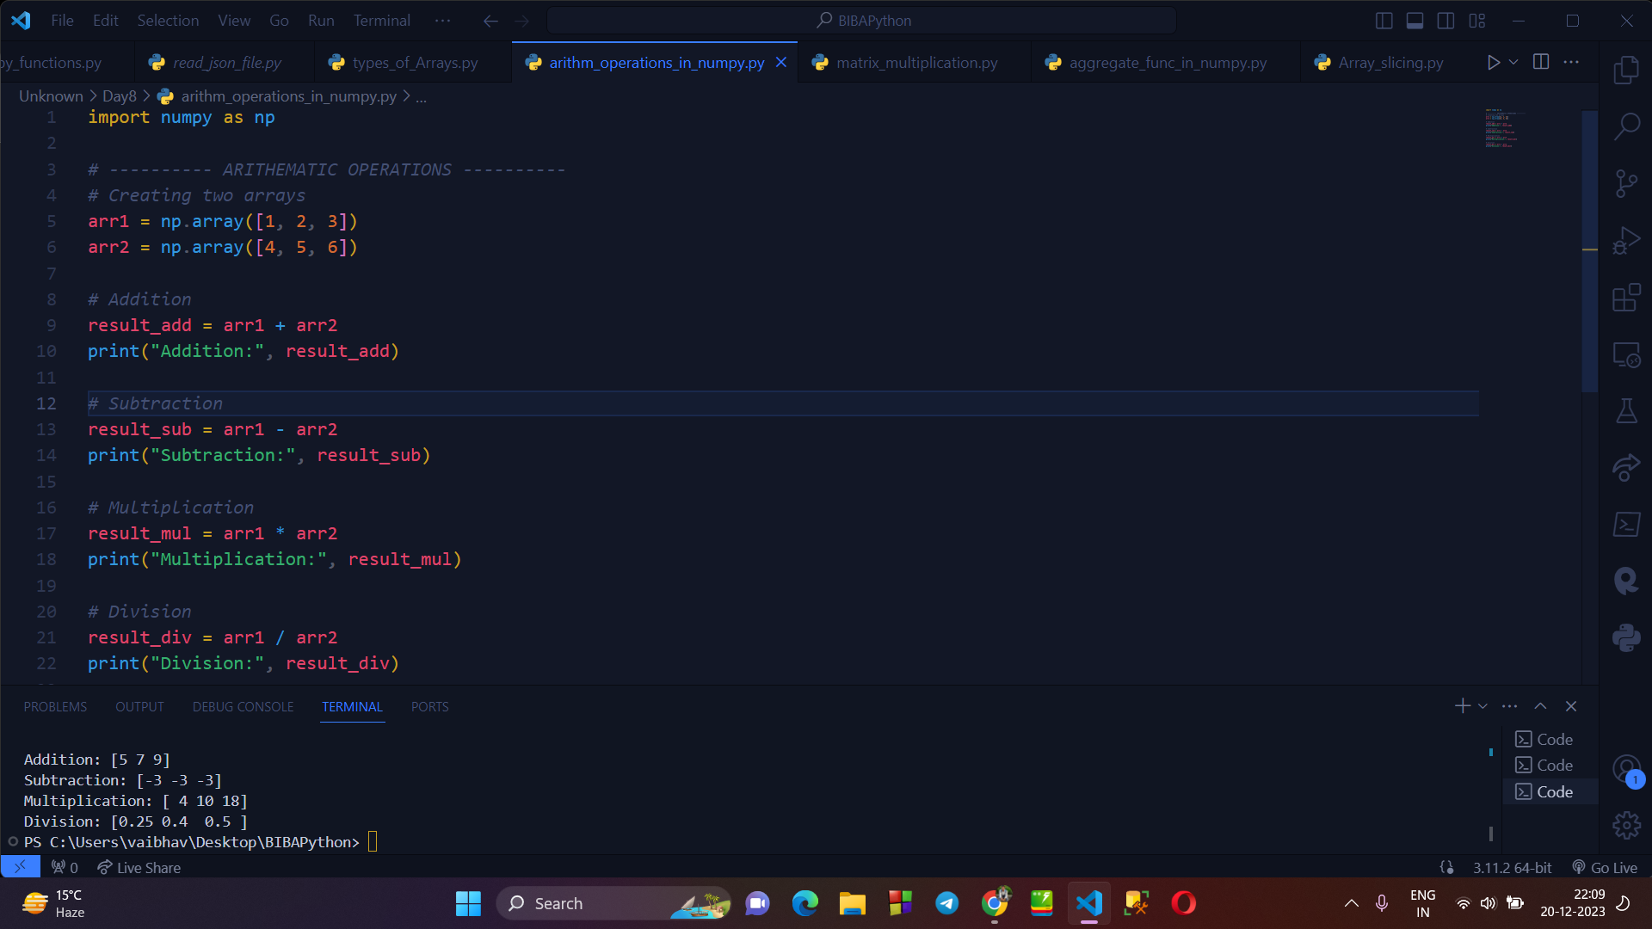

**→ Aggregation functions :**

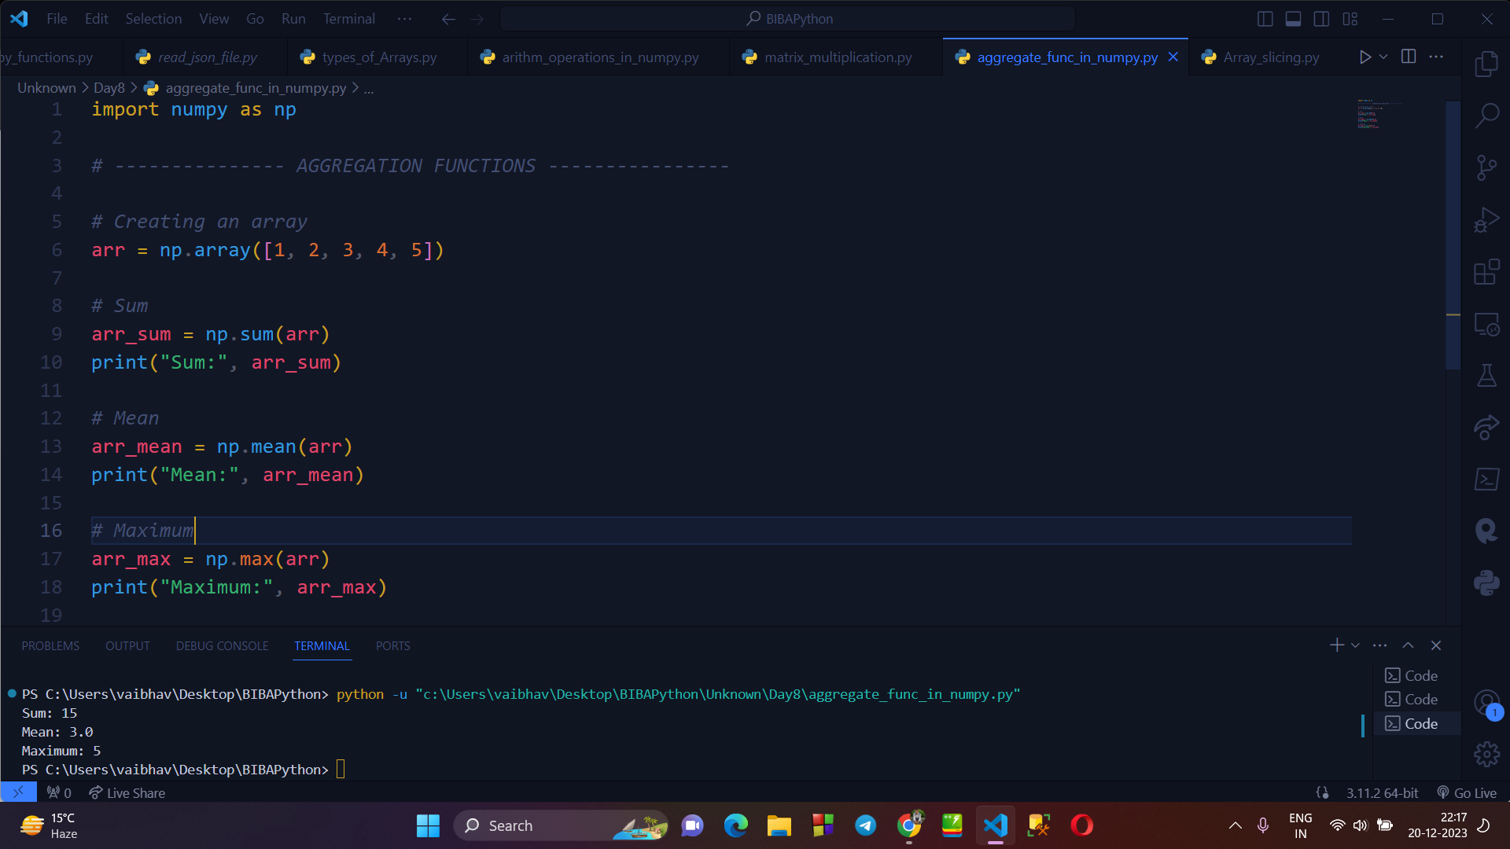

**→ Matrix Multiplication :**

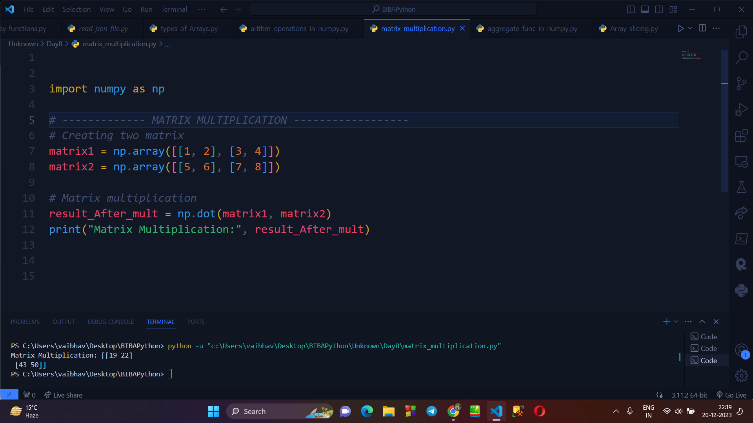

**→ Array Slicing :**

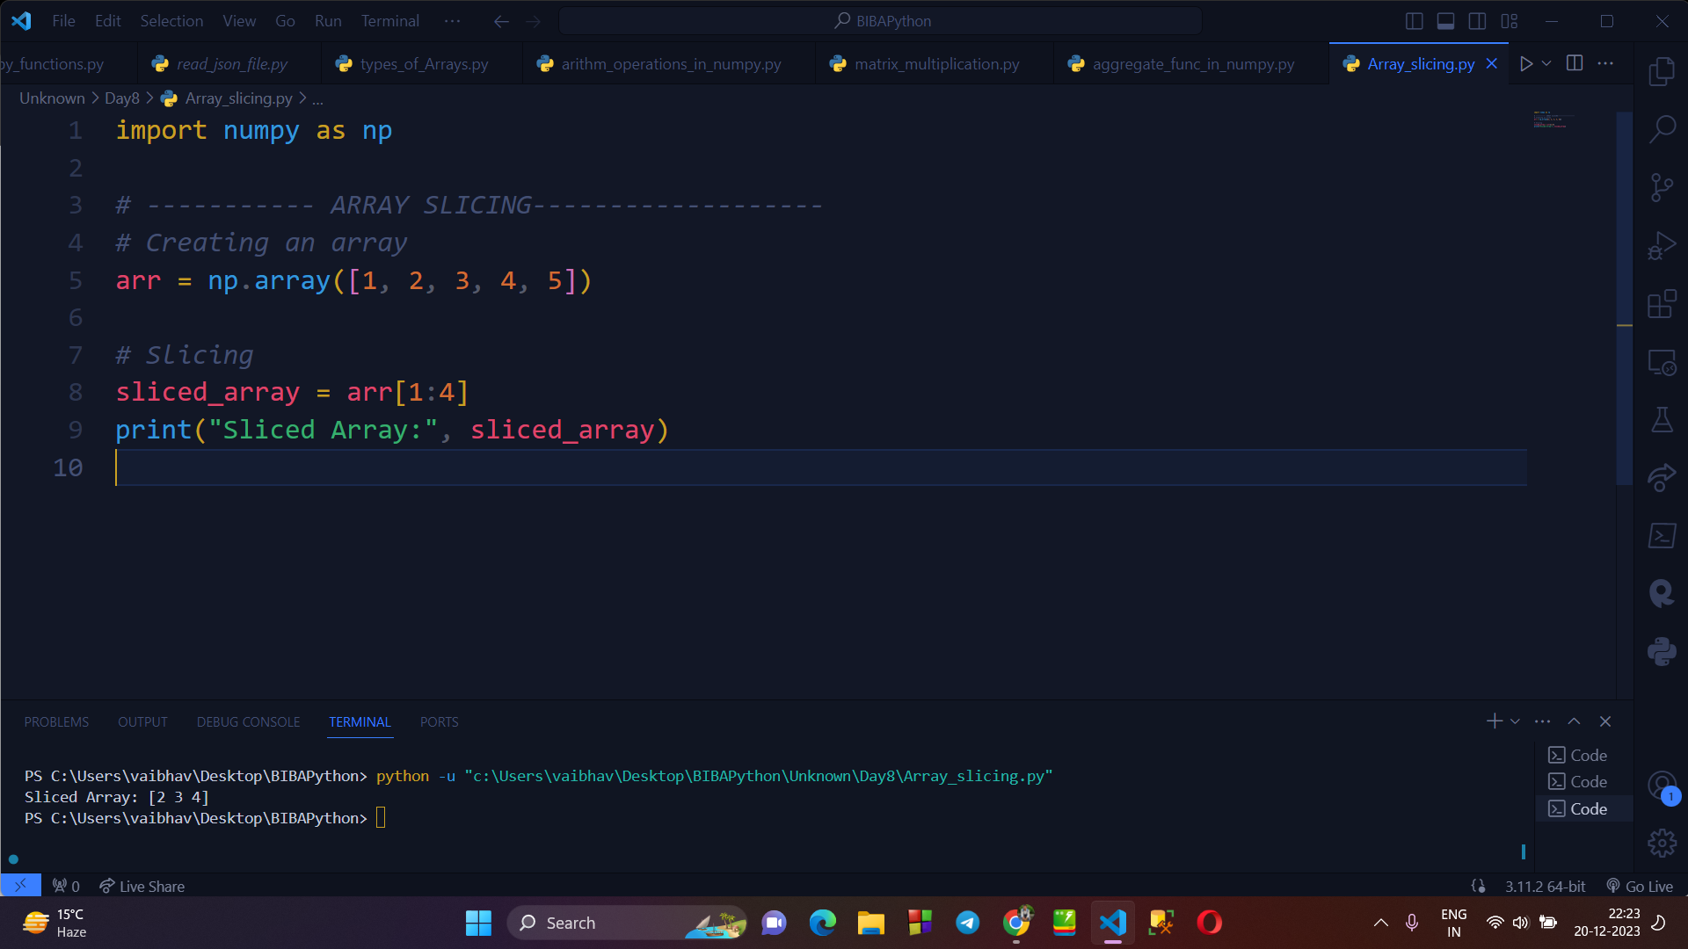

**→ ARRAY SORTING :** Numpy provides us several ways of sorting , which are as follows :

* Row-wise sorting
* Algorithm based sorting
* Sorting based on parameter.

**Program to demonstrate sorting :**

